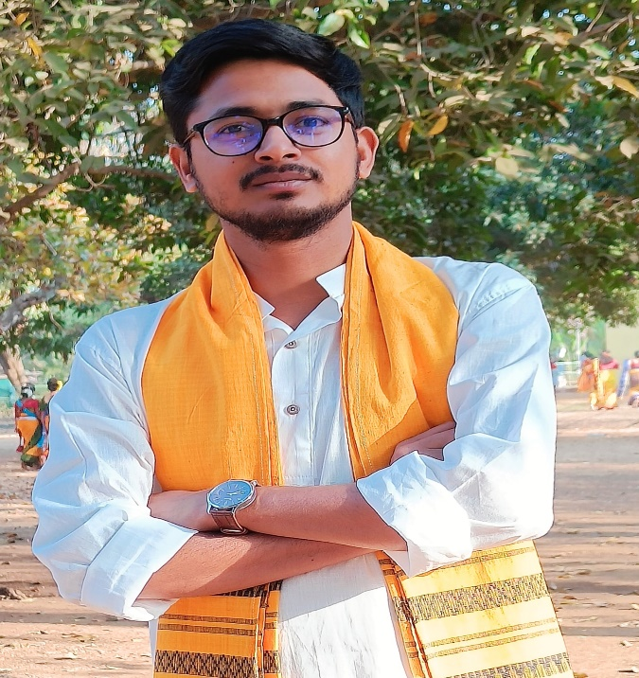

I am Rahul Pal, doing my M.Sc Physics from Visva-Bharati, Santiniketan.
I have done my M.Sc Project on "Simulation on photovoltaic device" ."Nuclear Physics'' is the special paper in my M.Sc Course.
Now I am preparing for CSIR NET.
I am interested in Experimental Physics & Coding.

Project Link :
https://drive.google.com/drive/folders/1Q0BrYhByWp-UGTaHR1VL-SBdSBHL8jpu?usp=sharing

THANK YOU

